Workshop Guide – Misinformation Related to Sustainable Development
This guide is intended to help educators to facilitate interactive workshops to help students to engage with and reflect on the theme of Misinformation Related to Sustainable Development. Accompanying guides and video resources are available on the Centre for Academic Practice’s Teaching Materials for ESD page. For more information on the background to these resources, please see the Acknowledgements section at the end of this document.
Table of Contents
Preparing for the workshop: 2
Learner/Student – In preparation for attendance at the workshop 2
Facilitator/ teachers – recommended teaching practices for in-person workshop 2
Workshop 5 - Session Plan (assumes that prework has been completed by learners) 3
Facilitator notes/ prompts aligned with workshop session plan 5
TASK #1: Group Presentation, Perspective 1: Influencer Yellow Handout #1, p1 11
Task 1: Workshop Scenario, Perspective 1: Influencer Yellow Handout #1, reverse p1 12
Devious frames (Grant Ennis, 2023), Vaping and Influencers. Yellow Handout #1, p2 13
TASK #1: Group Presentation, Perspective 2: Communications executive. Green Handout #1 15
Task 1 - Scenario, Perspective 2: Communications executive. Green Handout #1, rev p1 16
Devious frames (Grant Ennis, 2023) and Vaping and Comms Executive. Green Handout #1, p2 17
TASK #1: Group Presentation, Perspective 3: Policy Change Advocate. Blue Handout #1, p1 19
Task 1: Workshop Scenario Pers3: Young ‘Policy Change’ Advocate: Blue Handout #1 20
Devious frames (Grant Ennis, 2023), Vaping and Policy Advocate. Blue Handout #1, p2 21
Task #2: Group assignments. Handout #2. 23
SMART Upstream Goals (definitions of ‘Upstream [handbook page 5) 24
TASK #3: Student activity worksheet (individual). Handout #3 25
SMART Upstream Goals (definitions taken from [handbook page 5]) 26
Task #4 (Optional) - if required to be e.g. submitted end/post workshop. Handout #4 27
Theme/Block 5 Workshop References/ Works Cited: 29
Theme/Block 5 Workshop: Facilitator Checklist(s) Graduate Attribute in Focus= to Act Responsibly. Relevant behaviours highlighted in yellow. 32
Acknowledgements 33

Preparing for the workshop:

Learner/Student – In preparation for attendance at the workshop
- Attend (interactive) lectures and/or review videos and/ or reading assigned by workshop Leader: e.g. Grant Ennis Devious Frames.
- Prework before attending the workshop should include:
  - Review one of more scenarios, referred to as perspectives, as assigned.
  - Retain individual reflections for use in the workshops – for Perspective(s) assigned.
  - Access and review smoking/vaping related resources https://www.tcd.ie/healthytrinity/
- Prework might include consideration of, or reflection on, how they might advise each the three Laoise/Jo/Alex regarding the relevant scenarios provided.
- A module co-ordinator/curriculum team might additionally require students to upload to the Learning Management system 50-100 word ‘draft’ advice for each of the three (Laoise/Jo/Alex).
Recommendation from workshop authors:
- Learners should ideally complete for all three perspectives (Influencer – Laoise, Communications Executive - Jo, and Student Union’ President – Alex), so that they will be familiar with the different perspectives when they arrive at the workshop. Require earners to upload 50-100 word task in advance of the workshop. As learners will be assigned to groups/ perspectives when they arrive at the workshop, their group members (and their responses to the assigned Perspective) will provide the stimulus necessary for discussion, debate and negotiation.
- Learning Management Systems (LMS)/Virtual learning environments (VLE), or tools such as survey-monkey may be used to house and manage these activities.

Facilitator/ teachers – recommended teaching practices for in-person workshop
Printed templates for use during the workshop must be available to the facilitator. It is recommended that paper used for copying be colour-coded by the perspective as outlined.
- Perspective 1, Influencer, Laoise: Yellow.
- Perspective 2, Communications Executive, Jo: Green.
- Perspective 3, Student Union’ President, Alex: Blue.
Room setup:
- Tables/ system for small Groups. Flipcharts/ boards can be a useful addition.
- Ideally 5 students per group, three groups of 5 in a facilitator ‘set’.
- One facilitator ‘set’ per room is ideal, but more can be accommodated.

During the workshop (colour code by scenario perspective when photocopying):
Handout #1 has two pages. One is provided to each group.
- Page 1: Template for the group presentation and a copy of the assigned perspective.
- Page 2 provides detail on the nine devious Frames (Ennis, 2023). Pages: 9-11, 13-16, and 17-20.
Handout #2 has one page. One is provided to each group. Pages: 21-22.
- Template to document a group agreed question that aims to identify misinformation, from other groups presentations. The aim is to reveal clues about the misinformation they introduced.
- Template for group agreement as to what misinformation presenters deliberately introduced.
- Template for a SMART upstream goal, on vaping, to present to government representatives.
Handout #3 has one page. Support for reflection/ assessment. Provide one to each student. Page 23.
Guidance on preparation of upstream goals. Prompt questions to support individual reflection on presentations by other groups/perspectives at the end of/after the workshop.
Handout #4 provides an optional (assessable) template on which groups could prepare: a cogent, coherent proposal of one SMART upstream goal to address their perspective’s challenge. Page: 25.

Workshop 5 - Session Plan (assumes that prework has been completed by learners)
Theme/Block 5 Title: Misinformation related to sustainable development.
Theme/Block 5 aim(s): To introduce awareness of risks of misinformation to sustainable development and drive development of abilities that help discern between facts presented to support individual interests and facts that prioritise the greater good. (Trinity Graduate Attribute = Act Responsibly)
Learning Outcomes for this session – participants will be able to:  (i) Identify commonly applied misinformation related to challenging concepts in sustainable development and  (ii) Agree (group) SMART (specific, measurable, achievable, realistic and time-bound) upstream goals which address misinformation related to sustainable development. |  | Workshop  Duration: 1hrs50mins
Time | Activity | Students/parts
0 to 5m | Organise in tables, introduce to group members etc | 5mins – intro
5-10m | - Allocate one perspective plus 3 devious frames options (Ennis, 2022) from which to choose one frame, to each table/group.  Handout #1, includes scenario-plus-challenge integrated to the scenario, group activity sheet, Devious Frame options allocated, instructions, and information related to their perspective, and vaping. | 5mins
10-30m | Task #1: Groups prepare for presentation (perspective) to the room.  Format: 3 x max 1 minute presentations, key points on the template.  Emphasise/ clearly advise that groups must: present facts without lying, and to include, and make visible, a sample of misinformation. | 20mins
30-60m | Handout #2/ Task #2: required during presentations i.e. when your own group’s perspective presents to the other x2 groups after which  - 3 mins allowed for each other group to prepare/agree one question, that aims to identify and/or expose misinformation deliberately introduced by them, to ask each other group.  - The Question asked must be written on own group’s template.  - The group being asked the question must answer truthfully.  - The group asking the question must guess and document on own template what the misinformation is... but not disclose their guess to the room until all three groups have completed the Q&A | 30mins
60-80m | Facilitated session (3 x 5 mins), each group (Laoise/ Jo/ Alex) in turn:  - Laoise/Jo/Alex is told what others suspect is misinformation.  - Laoise/Jo/Alex must confirm or deny honestly.  - If misinformation is not accurately identified, the Laoise/Jo/Alex must disclose the ‘actual’ misinformation used. | 20 mins
80-105 | Task 3 - Facilitated session: With the freedom to step out of your assigned perspective if your group so chooses, your group must:  - Develop a SMART upstream goal relating to vaping that you will present to a government representative or Committee (10 mins).  - Each group presents for max 1 minute total, [up to three speakers]  - Reference to upstream goals should take account of the Healthy Trinity Handbook and lectorial/workshop preparation resources. | 3-5mins to introduce:  10mins (group prepares)  3 x 1 min  Up to 7 mins for wrapup.
105-110m | (Optional) prompt questions and closing session:  - Where did tension and discomfort arise when acting in your role as Laoise, Jo or Alex? Why, do you think, this tension arises?  - Discuss how misinformation might present differently from e.g.  (i) influencers, of which Laoise is one example?  (ii) marketing department employees, of which Jo is one example?  (iii) those advocating for policy change - Alex is one example? | 5mins

[Insert Blank Page if printing double-sided]

Facilitator notes/ prompts aligned with workshop session plan

Facilitator prompts/notes included under each item in the session plan.
Recommended teaching practices/activities determined by the workshop leader in each case.
Theme/Block 5 Title: Misinformation related to sustainable development.
Theme/Block 5 aim(s): To introduce awareness of risks of misinformation to sustainable development and drive development of abilities that help discern between facts presented to support individual interests rather than facts that prioritise the greater good. (Trinity Graduate Attribute = Act Responsibly)
Learning Outcomes for this session – participants will be able to:  (i) Identify commonly applied misinformation related to challenging concepts in sustainable development and  (ii) Agree (group) SMART (specific, measurable, achievable, realistic and time-bound) upstream goals which address misinformation related to sustainable development. |  | Workshop  Duration: 1hrs 50mins
Time | Activity | Students/parts
0 to 5m | Organise in tables, introduce to group members etc  Facilitator prompts/notes:  - Direct students so that they sit with ‘new’ people – encourage them to introduce themselves.  - All should have completed review of the case study, and they should be familiar with terms related to vaping and the roles in the scenarios: namely social media influencer (Laoise), communications officer/executive (Jo) and policy advocate (Alex).  - In the workshop there are no ‘right’ or ‘wrong’ answers – reassure that they will benefit more from this workshop if they take a curious approach to why others think differently and really try to share why their perspective differs. They might find that discussion, debate and negotiation leads them to adapt or amend their previously held view(s). That’s all part of what we aim to do in this workshop.  - There is role-play involved in this workshop - people can often get caught up in “playing the role”. Remind them of the instructions they are given and to make sure that the workshop is equal parts fun and taken seriously. | 5mins – intro
5-10m | - Allocate one perspective plus 3 devious frames options (Ennis, 2022) from which to choose one frame, to each table/group.  - Provide Handout #1, which includes perspective-specific scenario-plus-challenge integrated to the scenario, group activity sheet, Devious Frame options allocated, instructions, and information related to (a) their perspective, and (b) to vaping.  Facilitator prompts/notes:  Each group’s handout identifies their perspective-specific three of the nine Grant Ennis frames from which to choose and use one, and declare in advance of presenting, as follows:  - Laoise Yellow: Silver Boomerangs, Treatment OR Knotted Web  - Jo Green: Magic, Silver Boomerangs OR Victim Blaming.  - Alex Blue: Victim blaming, normalisation OR post-denialism.  - The first page handout #1 is your group workbook template to be filled in when preparing the presentation.  - The scenario/perspective, previously shared for prework, is visible on the other side of the first page.  - On the second page of Handout #1, you are provided with facts that your group may choose to utilise in your presentations. | 5mins
10-30m | Task #1: Groups prepare for presentation (perspective) to the room.  Format: 3 x max 1 minute presentations, key points on the template.  Emphasise/ clearly advise that groups must: present facts without lying, and to include, and make visible, a sample of misinformation.  Facilitator prompts/notes:  - Handout #2 is provided to each group to privately record the misinformation and devious frame include in their presentation.  - Participants include only group agreed responses on this template.  - If/as required by workshop/module leader(s):  - All students will sign this before the end of the workshop,  - The group is responsible for ensuring that the facilitator countersigns and dates this completed template before the end of the workshop.  - Each group member is responsible for ensuring they have a photo /record of this signed worksheet for return to their module leader/ upload to their [Journal]/ other.  - Group members work collaboratively to prepare a response to the challenge posed to (Laoise, Jo or Alex) in the scenario, so that the group can present to the room in the following format:  - 3 people x max 1 minute presentations,  - Key points for each speaker inserted on the template provided.  - Groups must: present facts without lying, which include, and make visible on template OR flipchart etc provided, a sample of misinformation.  - NO lies should be included. [define lie, for the purpose of this workshop as any of the following e.g. to make up, fabricate and/or invent a ‘fact’ … ].  - Share your group’s outline presentation with other groups: Other groups are given opportunity to photograph completed templates for each ‘perspective’, which must not be amended thereafter.  - Disclose to facilitator/on worksheet: The group names the primary devious frame used on the group worksheet – visible to the facilitator and declared to other groups before presenting. | 20mins
30-60 | Handout #2/ Task #2: required during presentations i.e. you’re your own group’s perspective presents to the other x2 groups after which  - 3 mins allowed for each other group to prepare/agree one question, that aims to identify and/or expose misinformation deliberately introduced, to ask each other group.  - The Question asked must be written on own group’s template.  - The group being asked the question must answer truthfully.  - The group asking the question must ‘guess’ what the misinformation is, and write it in their workbook so that the misinformation identified is visible to the facilitator, but not disclosed to the room until all three groups have completed the Q&A.  Facilitator prompts/notes:  - Each group should (already) have a copy of ‘Task #2  - One copy of Task #3 is given to every individual so that each individual student can ‘listen with intent’ and aim to record on the template what they believe is the other groups’ deliberately introduced misinformation while they are presenting.  - Remind groups that 3 minutes is the maximum but as long as 3 members speak it can be less than that.  - Agree the group question. Write the question on Task #2 handout.  - Inform the workshop that the questions asked to other groups must be agreed by the entire group AND must be solely based on the information they provided in their presentation.  - Each group, when being questioned, must agree on one person to answer each question truthfully i.e. must not make up, fabricate and/or invent a ‘fact’.  - Remind the workshop that no further discussion is to be had once the question is asked and answered. That will be had later. | 30mins
60-80 | Facilitated session (3x5 mins):- each group (Laoise/ Jo/ Alex) in turn:  - Laoise/Jo/Alex is told what others suspect is misinformation.  - Laoise/Jo/Alex must confirm or deny honestly.  - If misinformation is not accurately identified, the Laoise/Jo/Alex must disclose the ‘actual’ misinformation used.  Aims are that participants are able to (a) recognise deliberate misinformation and/ or (b) discuss how misinformation might present differently from influencers/ communications executive/ those advocating for policy change.  Facilitator prompts/notes:  - Groups are given a max of 3 minutes to agree the misinformation ‘deliberately introduced’ by each other group (announce when 3 minutes is up so they know to move onto deliberation related to next group). Write their decision on Task #2 handout.  - Facilitator selects one group to be questioned at a time and allow the group to reveal their actual misinformation only after both other groups have shared their ‘guess’ regarding misinformation.  - Once all revealed, open a discussion on (a) if they recognised deliberate methods of misinformation before (b) how misinformation may present differently in different contexts.  - Remind learners that the list of frames is non-exhaustive and that there are many different scenarios and devious frames in which misinformation can be identified.  - Facilitator should continue to assure/ observe that everyone is actively participating.  Scenarios, ‘facts’, Tips and references are available to students in advance of the workshop.  Confirm that students have access to these resources during the workshop. | 20 mins
80-105 | Facilitated session: With the freedom to step out of your assigned perspective if your group so chooses, your group must:  - Develop a SMART upstream goal relating to vaping that you will present to a government representative or Committee (10 mins).  - Each group presents for 1 mins total, [up to three speakers]  Reference to SMART upstream goals should take account of the Healthy Trinity Handbook and lectorial/workshop preparation resources.  Facilitator prompts/notes:  Specific: Does your goal identify a particular thing you want to change / impact?  Measurable: Will you be able to determine if you’ve made progress?  Achievable: Is your goal something you can realistically hope to achieve? You’re looking for something ambitious but achievable.  Realistic: Are you willing / able to work towards your goal? Can you get support?  Time-bound: Do you have a timeframe for accomplishing your goal?  - Up to 5 minutes to introduce this section – less time for introduction will enable more time for discussion at the end.  - Each group must prepare a single SMART recommendation either from their already assigned perspective or outside of this and be prepared to present it in a maximum of one minute – during which they can include up to three speakers.  - Each group should write their recommendations on their group’s Task #2 handout.  - Facilitator chooses order for the 3 groups to present (1min each)  - Facilitator should continue to assure/ observe that everyone is actively participating. | Q up to 5mins to introduce:  10mins (prepare)  3 x 1 min present  Up to 7 mins available for wrapup.
105-110m | (Optional) prompt questions and closing session:  - Where did tension and discomfort arise when acting in your role as Laoise, Jo or Alex? Why do you think this tension arises?  - Discuss how misinformation might present differently from e.g.  (i) influencers, of which Laoise is one example?  (ii) marketing department employees, of which Jo is one example?  (iii) those advocating for policy change - Alex is one example?  Facilitator prompts learners to : Consider what you have learned from engaging in the individual and group activities in this workshop, and answer the two prompt questions above.  General discussion, questions, further tutorials, resources etc.  Facilitator prompts/notes – if time allocated/included in curriculum:  - Facilitate discussion at the end if/as time allows: When discussing how misinformation might present differently from different perspectives consider using the following ‘facts’ to guide conversation/discussion  - Influencers are known to use these tactics of misinformation:  - use of emotion, rather than facts, to sway people,  - engage in ‘rumour-milling’ i.e. claim to have exclusive access to secrets which they present as being purposefully concealed, or  - aim to deflect attention from their own wrongdoings by alleging the wrongdoings of others. (i.e. ‘whataboutism’).  - Large companies known to use these tactics of misinformation:  - Utilise reference to networks of supposed “experts”, or prominent public figures whether or not experts, vouch for the company’s viewpoint.  - “Cherry-pick” statistics and facts and use them in isolation to better suit their narrative.  - Deflect attention to positive initiatives that they are associated with even if not particularly relevant to the topic under scrutiny.  - ‘Policy Change’ Advocates are known to use these tactics of misinformation:  - Place the focus of the discussion on a related but separate topic to distract attention away from the major issues (distraction).  - Create a false dichotomy of narratives i.e. only having one of two mutually exclusive options; i.e. good or bad.  - Claim that ‘multiple people’ have expressed concern surrounding the topic to them leading the listener to believe that large sections of society are concerned.  - Relate these back to the 9 Devious Frames  - General discussion, questions, further tutorials, resources etc. | 5mins

[Insert Blank Page if printing double-sided]

TASK #1: Group Presentation, Perspective 1: Influencer Yellow Handout #1, p1
[20mins preparation, plus 30mins presentations +questions]
Group assignments. Please complete all sections during the workshop. Ensure that the facilitator signs the completed worksheet for you before you leave. [Module coordinator directs]

[Prepare this template so that other groups can photograph it & can ‘see’ when you ‘present’.
Group’ presentation which addresses their perspective’s challenge (max300words)
1.

2.

3.

Student Name | Student signature
Facilitator initials | Facilitator name

Task 1: Workshop Scenario, Perspective 1: Influencer Yellow Handout #1, reverse p1
Laoise (@laoiseinlondon) is a sustainable lifestyle influencer with almost a million followers across several social media platforms. Recently, a major e-cigarette company offered her a deal: a box full of their disposable e-cigarettes and associated merchandise free of charge, and €7,500 for each post she makes featuring their e-cigarette products. As a young person living in an expensive city, she takes up the lucrative offer, making 10 posts explicitly promoting the use of disposable e-cigarettes to her audience for €75,000 total.
Her audience, being primarily young environmentalists, is angry with her promotion of a product they deem as wasteful. A fellow sustainable lifestyle influencer, Sal, makes a “call-out post” denouncing Laoise's advertisements based on the amount of plastic and rare earth metal wasted in the production of e-cigarettes, effectively “cancelling” her. After Sal's posts, Laoise decides to make a video responding to Sal's claims.
Activity Instructions: [20mins preparation, plus 30mins presentations +questions]:
Your group responds as if you are Laoise (Influencer) preparing a video to respond to Sal’s ‘call-out’:
- Format: 3 x maximum 1 minute presentations, with key points inserted on the template flipchart/whiteboard provided.
- Content: Groups must present facts without lying. NO lies should be included. [define lie, for the purpose of this workshop as any of the following: to make up, fabricate and/or invent a ‘fact’].
- Must include (while trying to ‘hide’!): Each group must include a sample of misinformation and make this visible to everyone at the workshop (flipchart/templates as provided).
- Share with others: Other groups are given opportunity to take a photo of completed templates for each ‘perspective’, which must not be amended thereafter.
- Disclose to facilitator/on worksheet: The group names the primary devious frame used on the group worksheet – visible to the facilitator and declared to other groups before presenting.

Using questions to help identify misinformation deliberately introduced by the other two groups
- Prepare appropriate question: Each other group agrees one question to ask of the presenting group (3 mins allowed). Their aim is to identify and/or expose the misinformation.
- Evidence of question prepared: The Question asked must be written on group’s own template.
- The group being questioned must answer truthfully i.e. not make up, fabricate or invent a ‘fact’.
- Evidence of ‘guess’ re misinformation deliberately introduced: The group asking the question must ‘guess’ what misinformation has been deliberately introduced, and write it on their workbook so that the misinformation identified is visible to the facilitator ... but not disclosed to the room until all three groups have completed the Q&A.
- Summary of key points being presented on the template provided. Once shared with other groups at the workshop, and they have photographed if they choose, these summaries remain available to all participants for the duration of the workshop.
- Misinformation deliberately introduced must be included in this written/shared summary.
- Your task is to identify the misinformation deliberately included in other groups’ presentations. Turn over this page for a list of facts that one might use and/or misuse.

Devious frames (Grant Ennis, 2023), Vaping and Influencers. Yellow Handout #1, p2
Laoise: Choose from Silver Boomerangs, Treatment or Knotted Web
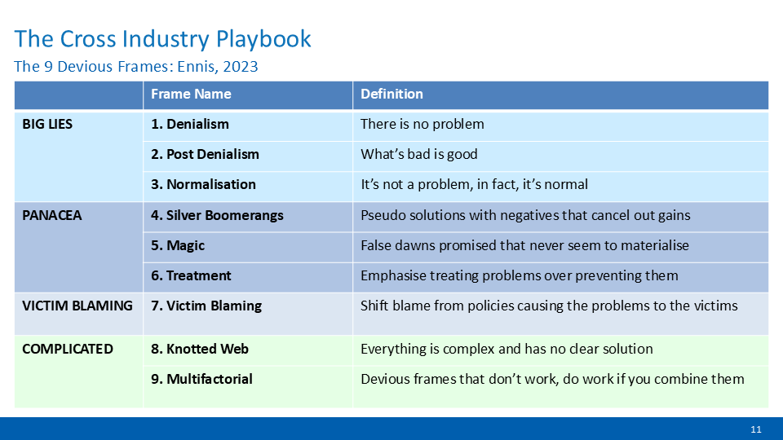
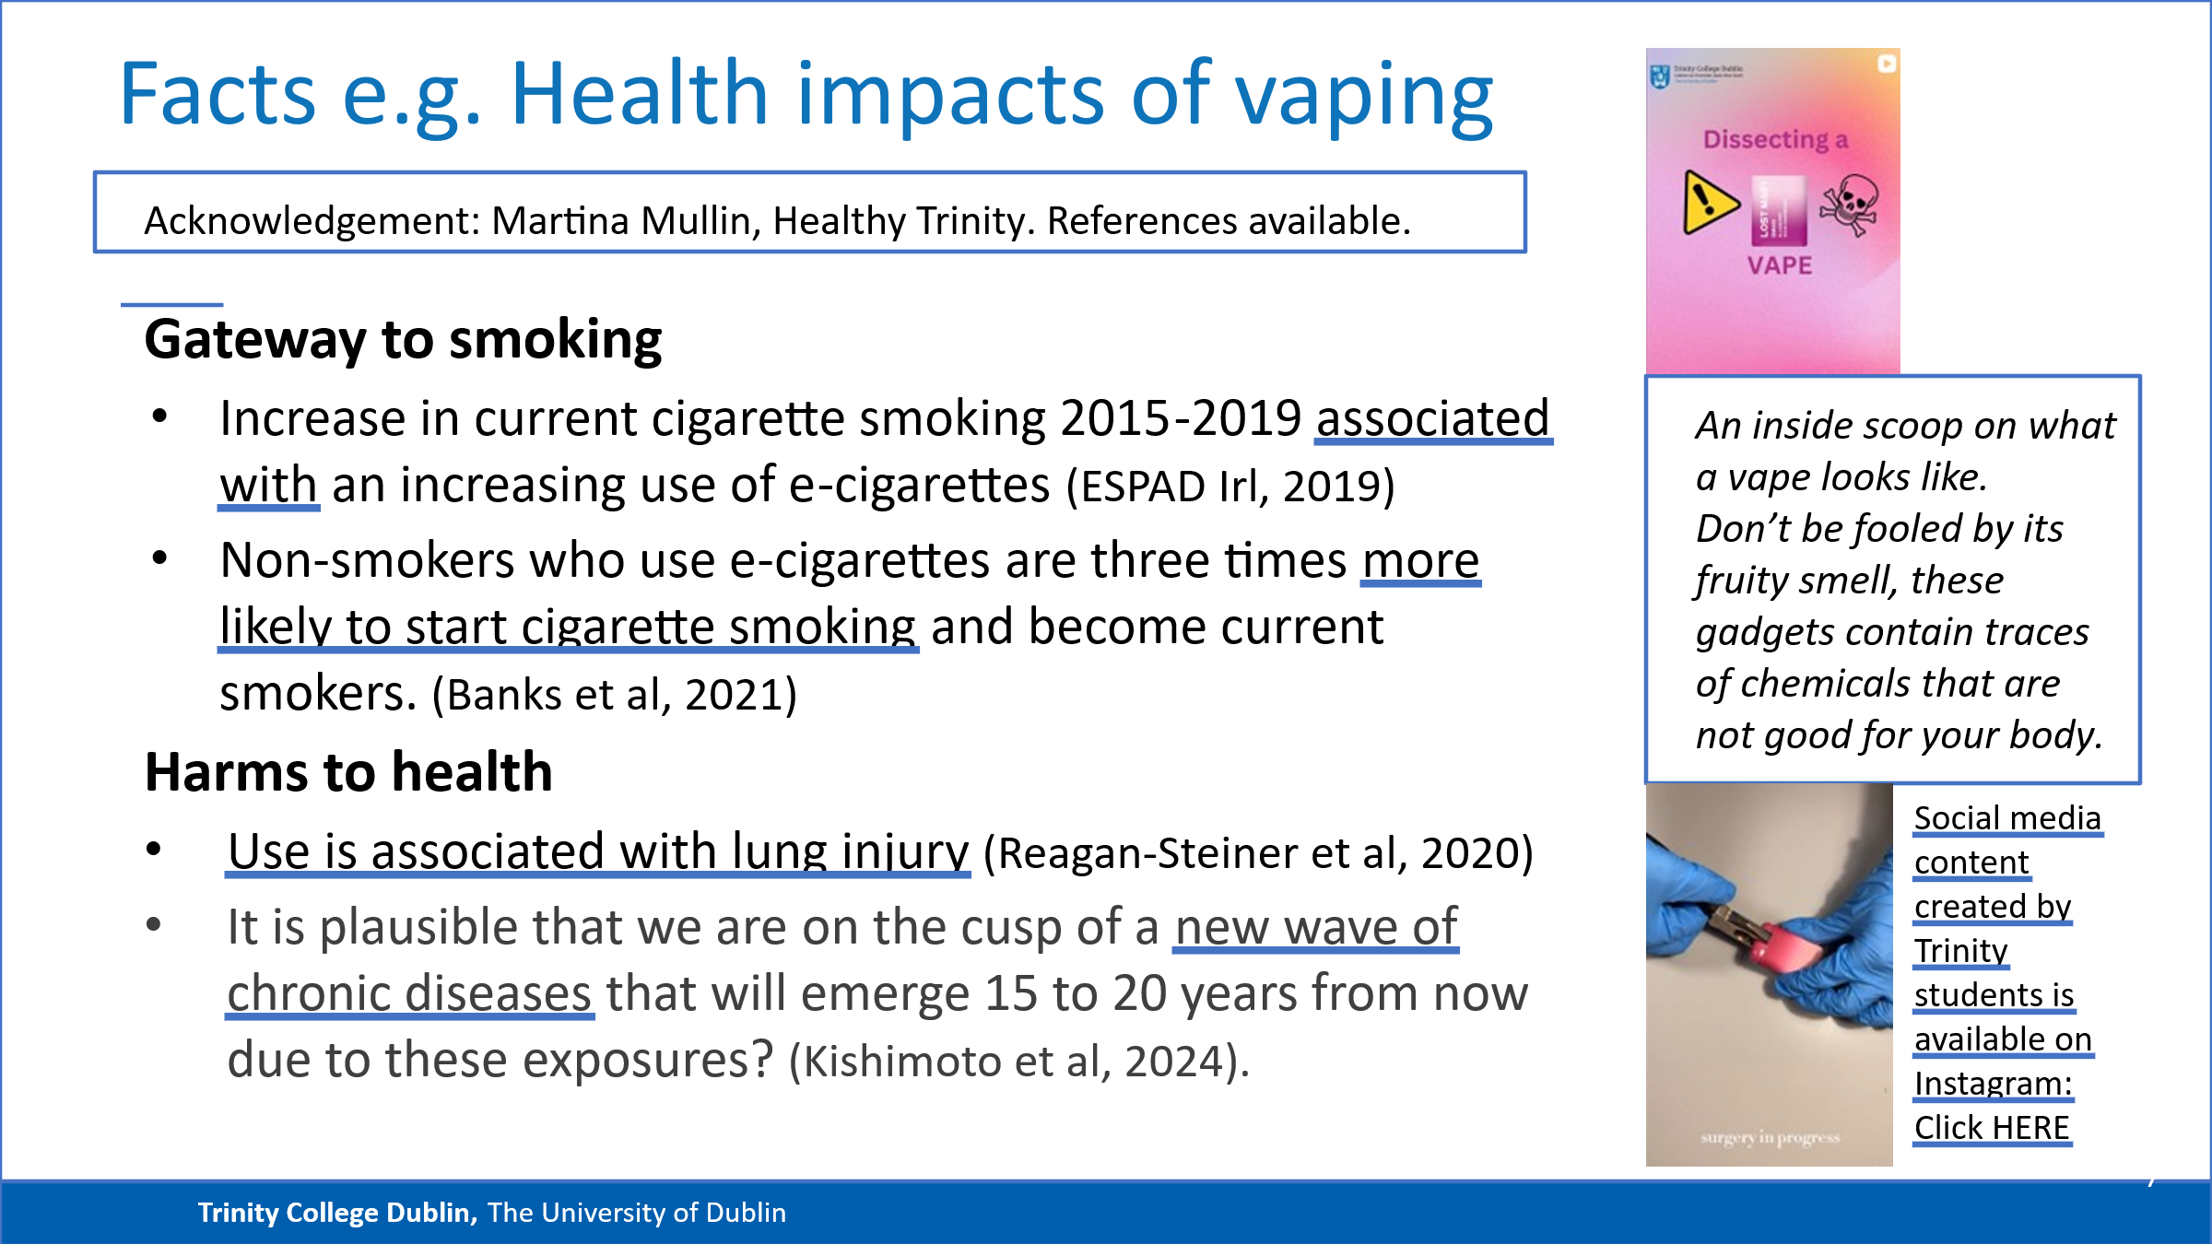

A selection of ‘facts’ that might be used by Laoise during the workshop
- Each year, the UK throws away 10 tonnes of lithium from disposable e-cigarettes (Askew, 2021).
- 10% of all vapes in Scotland become litter each year (Government of Scotland, 2023).
- 42% of e-cigarette users in Ireland believe that used disposable e-cigarettes can be thrown in the general refuse bin (European Recycling Platform, 2023).
- To recycle e-cigarette batteries, they must be fully taken apart, but are difficult to disassemble properly (Pashby, 2022).
- Lithium batteries are a fire risk when not properly discarded (Pourchez et al., 2022)

[Insert Blank Page if printing double-sided]

TASK #1: Group Presentation, Perspective 2: Communications executive. Green Handout #1
[20mins preparation, plus 30mins presentations +questions]
Group assignments. Please complete all sections during the workshop. Ensure that the facilitator signs the completed worksheet for you before you leave. [Module coordinator directs]

Prepare this template so that other groups can photograph it & can ‘see’ when you ‘present’.
Group’ presentation which addresses their perspective’s challenge (max300words)
1.

2.

3.

Student Name | Student signature
Facilitator initials | Facilitator name

Task 1 - Scenario, Perspective 2: Communications executive. Green Handout #1, rev p1
SuckIt is a prominent company in the e-cigarette industry focused on single-use e-cigarette vending machines used primarily in bars, clubs, and casinos. However, the absence of age verification when vending machines are used has prompted regulatory concerns. In response to growing concerns about the accessibility of vaping products, the government has responded by proposing legislation that specifically prohibits the supply of e-cigarettes from vending machines nationwide. Government policy seeks to dramatically reduce the prevalence of vaping, and to prevent minors (under 18 years of age) from having access to e-cigarettes containing nicotine products. The legislation proposed would support this policy aim.
As you, Jo, are the communications executive in the marketing department of SuckIt, you've been asked to prepare a statement persuading the public that e-cigarette vending machines represent a reduction in risk and are to be encouraged. Your company’s research has identified that your consumers, primarily people 18-25, are environmentally conscious. Legislators are therefore interested in including the youth voice in the new legislation. With this in mind, swaying the minds of your consumers is important for the long-term success of the business.
Activity Instructions: [20mins preparation, plus 30mins presentations +questions]
Your group responds as if you are Jo (Communication Executive) preparing a statement persuading your main consumer base that e-cigarette vending machines are of benefit:
- Format: 3 x maximum 1 minute presentations, with key points inserted on the template flipchart/whiteboard provided.
- Content: Groups must present facts without lying. NO lies should be included. [define lie, for the purpose of this workshop as any of the following: to make up, fabricate and/or invent a ‘fact’].
- Must include (while trying to ‘hide’!): Each group must include a sample of misinformation and make this visible to everyone at the workshop (flipchart/templates as provided).
- Share with others: Other groups are given opportunity to take a photo of completed templates for each ‘perspective’, which must not be amended thereafter.
- Disclose to facilitator/on worksheet: The group names the primary frame used on the group worksheet – visible to the facilitator and declared to other groups before presenting.

Using questions to help identify misinformation deliberately introduced by the other two groups
- Prepare appropriate question: Each other group agrees one question to ask of the presenting group (3 mins allowed). Their aim is to identify and/or expose the misinformation.
- Evidence of question prepared: The Question asked must be written on group’s own template.
- The group being questioned must answer truthfully i.e. not make up, fabricate or invent a ‘fact’.
- Evidence of ‘guess’ re misinformation deliberately introduced: The group asking the question must ‘guess’ what misinformation has been deliberately introduced, and write it on their workbook so that the misinformation identified is visible to the facilitator ... but not disclosed to the room until all three groups have completed the Q&A.
- Summary of key points being presented on the template provided. Once shared with other groups at the workshop, and they have photographed if they choose, these summaries remain available to all participants for the duration of the workshop.
- Misinformation deliberately introduced must be included in this written/shared summary.
- Your task is to identify the misinformation deliberately included in other groups’ presentations. Turn over this page for a list of facts that one might use and/or misuse.

Devious frames (Grant Ennis, 2023) and Vaping and Comms Executive. Green Handout #1, p2
Jo: Choose from Magic, Silver Boomerangs or Victim Blaming
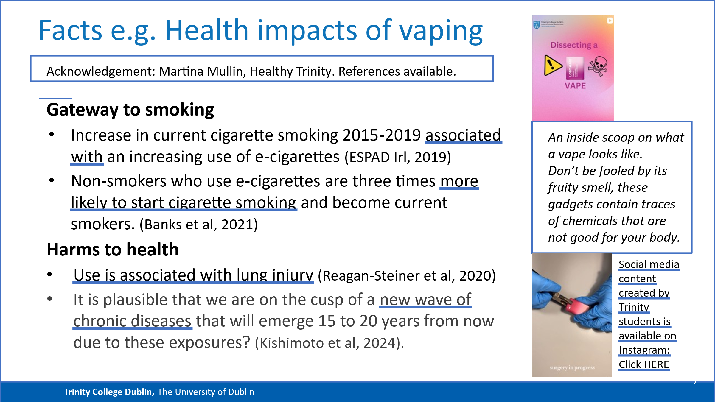
A selection of ‘facts’ that might be used by Jo during the workshop
- Systematic review of evidence in the literature has demonstrated an association between use of vapes in children and adolescents and other health problems including asthma, mental health problems, cough, alcohol use and marijuana use (Royal College of Physicians Ireland, 2023).
- In 2025, 42% of young people aged 11-17 used disposable vapes, a decrease from 2023 (69%). There was more than a 7-fold increase in disposable vape use between 2020 and 2022 but a disposable vape ban came into effect in May 2025. Data on disposable vape use since then are not yet available (ASH UK, 2025)
- A 2024 review of 107 studies and 124 odds ratios found e-cigarette use increased odds of cardiovascular disease, stroke, asthma and lung disease and that e-cigarettes are a gateway to tobacco smoking. Glantz et al, 2024 https://pubmed.ncbi.nlm.nih.gov/38411454/
- Systematic review of evidence in the literature has demonstrated an association between use of vapes in children and adolescents and other health problems including asthma, mental health problems, cough, alcohol use and marijuana use (Faculty of Paediatrics, Royal College of Physicians Ireland, 2023).
- Data also shows that teenagers who vape have a 3- to-5-fold risk of moving onto tobacco smoking (Quigley et al., 2020).
- Dual-use (using both vapes/e-cigarettes and conventional cigarettes) is the most prevalent behaviour among adolescent nicotine product users in Ireland (Bowe et al., 2021).

[Insert Blank Page if printing double-sided]

TASK #1: Group Presentation, Perspective 3: Policy Change Advocate. Blue Handout #1, p1
[20mins preparation, plus 30mins presentations +questions]
Group assignments. Please complete all sections during the workshop. Ensure that the facilitator signs the completed worksheet for you before you leave. [Module coordinator directs]

[Prepare this template so that other groups can photograph it & can ‘see’ when you ‘present’.
Group’ presentation which addresses their perspective’s challenge (max300words)
1.

2.

3.

Student Name | Student signature
Facilitator initials | Facilitator name

Task 1: Workshop Scenario Pers3: Young ‘Policy Change’ Advocate: Blue Handout #1
Alex is the TCD Student Union's (TCDSU) President and is an e-cigarette user. Recently, the government approached student unions across the country, as well as a prominent youth group comprised of under-18s Comhairle na nÓg (Youth Council), for consultation on newly proposed legislation. This legislation aims to drastically reduce the significant environmental impact associated with vaping. Reducing the prevalence of vaping amongst young people will benefit them and also be good for the environment.
Alex, on behalf of the TCDSU, argues that this legislation restricts consumer freedom, and that if an e-cigarette user wants to quit vaping for the good of the environment they will do so. In addition, if young people really want to use nicotine products, they will access them by any means necessary, even if further legal restrictions are placed on the product. However, Comhairle na nÓg's representative argues that young people are consistently targeted in e-cigarette advertising, despite being more vulnerable to any potential health risks. Additionally, the representative expresses concern regarding the quantity of plastic waste disposable e-cigarettes produce, even when all recycling practices are followed.
Activity Instructions: [20mins preparation, plus 30mins presentations +questions]
Your group responds as if you are Alex (TCDSU President) preparing a speech to respond to Comhairle na nÓg’s claims.
- Format: 3 x maximum 1 minute presentations, with key points inserted on the template flipchart/whiteboard provided.
- Content: Groups must present facts without lying. NO lies should be included. [define lie, for the purpose of this workshop as any of the following: to make up, fabricate and/or invent a ‘fact’].
- Must include (while trying to ‘hide’!): Each group must include a sample of misinformation and make this visible to everyone at the workshop (flipchart/templates as provided).
- Share with others: Other groups are given opportunity to take a photo of completed templates for each ‘perspective’, which must not be amended thereafter.
- Disclose to facilitator/on worksheet: The group names the primary devious frame used on the group worksheet – visible to the facilitator and declared to other groups before presenting.

Using questions to help identify misinformation deliberately introduced by the other two groups
- Prepare appropriate question: Each other group agrees one question to ask of the presenting group (3 mins allowed). Their aim is to identify and/or expose the misinformation.
- Evidence of question prepared: The Question asked must be written on group’s own template.
- The group being questioned must answer truthfully i.e. not make up, fabricate or invent a ‘fact’.
- Evidence of ‘guess’ re misinformation deliberately introduced: The group asking the question must ‘guess’ what misinformation has been deliberately introduced, and write it on their workbook so that the misinformation identified is visible to the facilitator ... but not disclosed to the room until all three groups have completed the Q&A.
- Summary of key points being presented on the template provided. Once shared with other groups at the workshop, and they have photographed if they choose, these summaries remain available to all participants for the duration of the workshop.
- Misinformation deliberately introduced must be included in this written/shared summary.
- Your task is to identify the misinformation deliberately included in other groups’ presentations. Turn over this page for a list of facts that one might use and/or misuse.

Devious frames (Grant Ennis, 2023), Vaping and Policy Advocate. Blue Handout #1, p2
Alex: Choose from Victim blaming, normalisation or post-denialism
A selection of ‘facts’ that might be used by Alex during the workshop
- One UK study found that 50% of single use vapes are thrown away. This equates to 1.3 million single-use vapes/week, which in one year is enough to cover 22 football pitches (Material Focus, 2022).
- Disposable vapes also contain hazardous heavy metals (e.g., mercury, lead and bromides) and other toxic chemicals (battery acid, lithium, nicotine), which leach into the environment when not properly discarded (Chapman, 2022).
- UK research found that annually, approximately 10 tonnes of lithium is wasted from discarded disposable vapes – the equivalent of 1,200 electric vehicle batteries (European Recycling Platform, 2023).
- Extraction and purification of nicotine from the tobacco plant for e-cigarettes requires a large amount of water and generates non-recyclable halogenated waste and pollution (Beutel et al., 2021).
- E-cigarette vapours are potent sources of air pollution such as aldehydes, carbon monoxide, particulate matter (PM), VOCs, heavy metals, and nicotine (Lee et al., 2017).

[Insert Blank Page if printing double-sided]

Task #2: Group assignments. Handout #2. Please complete all sections during the workshop. Ensure the facilitator signs the completed worksheet for you before you leave.
In your group presentation, identify the misinformation and the Devious Frame used.  Do NOT show this to the other groups. | Misinformation deliberately introduced (own group):  Devious Frame used (your own group):
After each presentation, each group collaborates (2-3mins) to structure a question to ask the group, with the aim of revealing the misinformation introduced.  The appointed member asks this question of the group: | Group 1: perspective reviewed =  Question: | Group 2: perspective reviewed =  Question:
Each group then revisits the [FACTs] for the ‘other two perspectives in the context of the presentations made. 10 mins is allowed for each. In that time the group’s tasks are to:
Name of ‘Devious Frame’ the group declare they have used.  Propose what the deliberately introduced misinformation is likely to be.  c)Prepare one SMART upstream goal relating to vaping that you will present to a government representative or Committee*  [*or equivalent depending on context of learners]. | Group 1: perspective  (a)  (b)  (c) | Group 2: perspective  (a)  (b)  (c)

SMART Upstream Goals (definitions of ‘Upstream [handbook page 5)
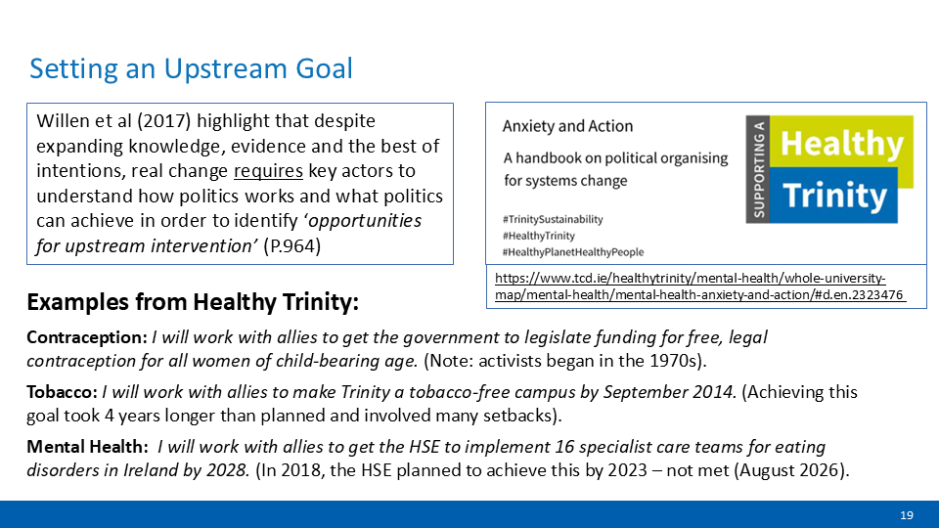
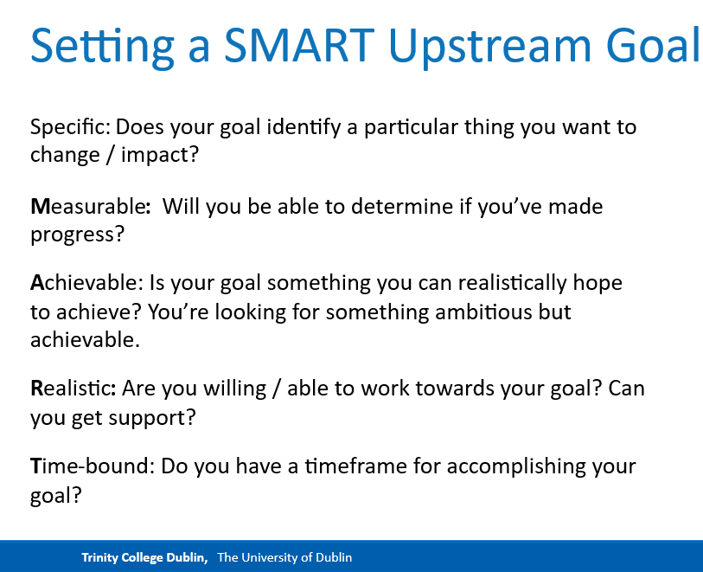

TASK #3: Student activity worksheet (individual). Handout #3 Please complete all sections. Ensure that the facilitator signs your (individual) completed worksheet before you leave.
Activity during workshop | Group 1: perspective reviewed = | Group 2: perspective reviewed =
While listening to the presentation, each student writes down your ‘guess’ regarding what you believe most likely to be misinformation. | (i) | (i)
While listening to the presentations, each student prepares (and writes down) a question that aims to expose the misinformation identified: | (i) | (i)
Self-directed learning / reflection at end of the workshop/ after the workshop (if MC directs):
Consider what you have learned from engaging in the individual and group activities in this workshop, and answer the following prompt questions i.e.
Where did tension and discomfort arise when acting in your role?

Why do think this is?

Discuss how misinformation might present differently from e.g.
(i) influencers?

(ii) marketing departments?

(iii) those advocating for policy change?

Prepare one SMART upstream goal relating to vaping that you will present to a government representative or Committee*. (*or equivalent).

Facilitator Name:
Facilitator Initial confirming completion of activity sheet: |  | Date:
Student name:

SMART Upstream Goals (definitions taken from [handbook page 5])
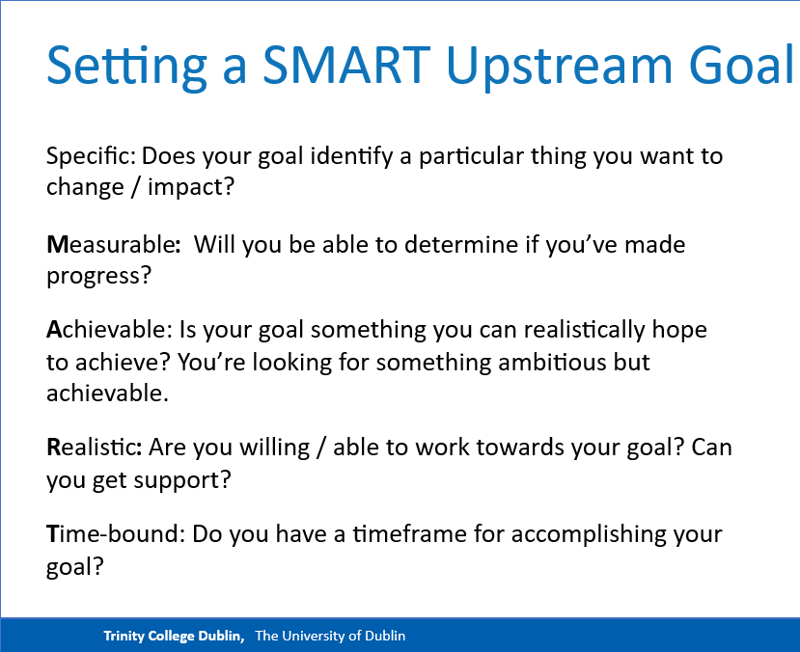

Task #4 (Optional) - if required to be e.g. submitted end/post workshop. Handout #4
Group members should ensure that you do not use this template for ‘rough-work’
Adapted version of group’ presentation which address their ‘perspective’s challenge
( maximum 300words)
1.

2.

3.

Student Name | Student signature
Facilitator initials | Facilitator name

[Insert blank page if printing double-sided]

Theme/Block 5 Workshop References/ Works Cited:
ASH UK. Summary of Key Findings Use of E-Cigarettes (Vapes) among Young People in Great Britain. 2025, https://ash.org.uk/resources/view/use-of-e-cigarettes-among-young-people-in-great-britain
Barnes, Oliver, and Alexandra Heal. “The Environmental Cost of Single-Use Vapes.” Financial Times, 7 Mar. 2023, www.ft.com/content/6d5ed980-8b91-4372-9e7e-14eda5419325.
Beutel, Marc W., et al. “A Review of Environmental Pollution from the Use and Disposal of Cigarettes and Electronic Cigarettes: Contaminants, Sources, and Impacts.” Sustainability, vol. 13, no. 23, Nov. 2021, p. 12994, https://doi.org/10.3390/su132312994.
Bowe, Andrea K., et al. “E-Cigarette-Only and Dual Use among Adolescents in Ireland: Emerging Behaviours with Different Risk Profiles.” International Journal of Environmental Research and Public Health, vol. 18, no. 1, Jan. 2021, p. 332, https://doi.org/10.3390/ijerph18010332. Accessed 30 Mar. 2022.
byndadmin. “Vapes Are Toxic Waste Polluting Our Environment - UNDO.org.” California Tobacco Control Program, 22 Mar. 2022, www.undo.org/environmental-impact/vape-waste-is-toxic-waste#sources-10.
Chang, Hoshing. “Research Gaps Related to the Environmental Impacts of Electronic Cigarettes.” Tobacco Control, vol. 23, no. suppl 2, Apr. 2014, pp. ii54–58, https://doi.org/10.1136/tobaccocontrol-2013-051480.
Chapman, Matthew. “Rise of Single-Use Vapes Sending Tonnes of Lithium to Landfill.” The Bureau of Investigative Journalism (En-GB), 15 July 2022, www.thebureauinvestigates.com/stories/2022-07-15/rise-of-single-use-vapes-sending-tonnes-of-lithium-to-landfill.
European School Survey Project on Alcohol and Other Drugs. Results from the European School Survey Project on Alcohol and Other Drugs the ESPAD Group. 2019. Accessed 3 Dec. 2023.
Faculty of Paediatrics, Royal College of Physicians Ireland. Disposable Vapes and Young People. Oct. 2023. Accessed 3 Dec. 2023.
Frost, Rosie. “Big Tobacco Is One of the World’s ‘Biggest Polluters’, Says WHO.” Euronews, 31 May 2022, www.euronews.com/green/2022/05/31/big-tobacco-is-having-a-devastating-impact-on-the-environment-who-report-reveals.
Glanz et al (2024) Population-Based Disease Odds for E-Cigarettes and Dual Use versus Cigarettes https://pubmed.ncbi.nlm.nih.gov/38411454/
Government of Scotland. “Tackling the Environmental Impact of Disposable Vapes.” Www.gov.scot, 30 June 2023, www.gov.scot/news/tackling-the-environmental-impact-of-disposable-vapes/.
Gutterman, Lucas. “Vape Waste: The Environmental Harms of Disposable Vapes.” PIRG, Public Interest Network, 11 July 2023, pirg.org/resources/vape-waste-the-environmental-harms-of-disposable-vapes/. Accessed 3 Dec. 2023.
HSE (2022). Press release - HSE Environmental Health Service takes market surveillance action against certain disposable e-cigarettes https://www.hse.ie/eng/services/news/media/pressrel/hse-environmental-healthservice-takes-market-surveillance-action-against-certain-disposable-e-cigarettes.html
Krause, Max J., and Timothy G. Townsend. “Hazardous Waste Status of Discarded Electronic Cigarettes.” Waste Management, vol. 39, no. 1, May 2015, pp. 57–62, https://doi.org/10.1016/j.wasman.2015.02.005. Accessed 4 Oct. 2019.
Lee, Mi-Sun, et al. “Nicotine, Aerosol Particles, Carbonyls and Volatile Organic Compounds in Tobacco- and Menthol-Flavored E-Cigarettes.” Environmental Health, vol. 16, no. 1, Apr. 2017, https://doi.org/10.1186/s12940-017-0249-x.
Material Focus. “One Million Single Use Vapes Thrown Away Every Week Contributing to the Growing E-Waste Challenge in the UK.” Material Focus, 15 July 2022, www.materialfocus.org.uk/press-releases/one-million-single-use-vapes-thrown-away-every-week-contributing-to-the-growing-e-waste-challenge-in-the-uk/.
McFarling, Meghan. “The Environmental Impacts of Vaping That the Tobacco Industry Doesn’t Want You to Know.” The Association for Nonsmokers-Minnesota, 31 Aug. 2022, www.ansrmn.org/the-environmental-impacts-of-vaping-that-the-tobacco-industry-doesnt-want-you-to-know/.
Pashby, Tom. “Disposable Vapes – a Challenge to the Recycling Sector - IEMA.” Www.iema.net, 9 May 2022, www.iema.net/articles/disposable-vapes-a-challenge-to-the-recycling-sector.
Pourchez, Jérémie, et al. “From Smoking to Vaping: A New Environmental Threat?” The Lancet Respiratory Medicine, vol. 10, no. 7, May 2022, https://doi.org/10.1016/s2213-2600(22)00187-4.
Quigley, Joan, et al. Electronic Cigarettes and Smoking Cessation: An Evidence Review. 2020, www.hrb.ie/fileadmin/2._Plugin_related_files/Publications/2020_publication-related_files/2020_HIE/Evidence_Centre/Electronic_cigarettes_and_smoking_cessation_systematic_evidence_review.pdf. Accessed 3 Dec. 2023.
Royal College of Paediatrics and Children's Health. Policy Briefing: Vaping in Young People. 6 June 2023, www.rcpch.ac.uk/sites/default/files/generated-pdf/document/Policy-briefing%253A-Vaping-in-young-people-.pdf. Accessed 3 Dec. 2023.
Trinity College Dublin Healthy Trinity Mental Health Group. (2024). Anxiety and Action. A Handbook on political organising for systems change. Available at: Anxiety_20and_20Action_20Handbook_20June_202024.pdf.pdf Last accessed 7th August 2026.
UNEP. ON the CONTROL of TRANSBOUNDARY MOVEMENTS of HAZARDOUS WASTES and THEIR DISPOSAL BASEL CONVENTION PROTOCOL on LIABILITY and COMPENSATION for DAMAGE RESULTING from TRANSBOUNDARY MOVEMENTS of HAZARDOUS WASTES and THEIR DISPOSAL TEXTS and ANNEXES. 22 Mar. 1989, www.basel.int/Portals/4/Basel%20Convention/docs/text/BaselConventionText-e.pdf.
Willen SS, Knipper M, Abadía-Barrero CE, Davidovitch N. Syndemic vulnerability and the right to health. Lancet. 2017 Mar 4;389(10072):964-977. doi:10.1016/S0140-6736(17)30261-1 PMID: 28271847.
World Health Organization. “Tobacco: E-Cigarettes.” Www.who.int, 25 May 2022, www.who.int/news-room/questions-and-answers/item/tobacco-e-cigarettes

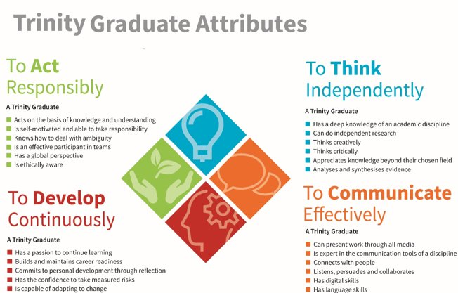

Theme/Block 5 Workshop: Facilitator Checklist(s) Graduate Attribute in Focus= to Act Responsibly. Relevant behaviours highlighted in yellow.
TA name:  Date: |  | Workshop |  |  |  | Completes prework as required and engages in activities in Workshop to demonstrate the ability to ‘Act responsibly– Mark out of xx according to rubric provided. GAs ‘Think independently’, ‘communicate effectively’, and ‘develop continuously’ noted.
Workshop outline | Student -à |  |  |  | 1 | 2 | 3 | 4 | 5 | 6 | 7 | 8 | 9 | 10 | 11 | 12 | 13 | 14 | 15 | 16
Workshop outline | Chair |  | Speaker | Q&A
Overall prework:
insert additional as appropriate
Shares responses to 3 perspectives at workshop
Learning outcome demonstration (1 of 2)
Is an active and ethical participant in teams e.g. presents, asks questions and/or responds (AR)
Is ethically aware e.g. identifies misinformation used during the workshop (AR)
Demonstration of Learning outcome: yes/no
‘Thinks’ Critically and/or ‘Thinks’ Creatively (TI)
Listens, persuades and collaborates and/or has language skills (CE)
Has confidence to take measured risks and/ or is capable of adapting to change (DC)
Workshop activities
Present pre-formed opinions to group (1-2 mins)
Engage to develop group presentation & frame(s).
Pitch, answer question(s) and/or pose question(s)
Completes feedback template to 2 x other groups
Complete & Submit final group work (End/after WS)
OVERALL [Pass/Fail OR Mark - as required by Module co-ordinator / Assessment Guide

Acknowledgements

Version 1.0 – 17/08/26
Centre for Academic Practice
Trinity Teaching and Learning
Trinity College Dublin

These materials are derived from development of a module, Enacting Education for Sustainable Development, co-developed by members of Trinity College Dublin’s academic staff, Carlos Rocha, Cicely Roche, Clare Kelly, Felix Mezzanotte, John Gallagher and Sarah-Jane Cullinane as part of their roles as Fellows in Education for Sustainable Development in 2023-2024 – and Trinity College Dublin students Freddie Fallon, Maryam Yabo, Tom Hegarty and William Reynolds as part of their roles as Education for Sustainable Development Interns in 2023-2024.
This work was funded by the National Forum/Higher Education Authority under the Strategic Alignment of Teaching and Learning Enhancement Fund.

Header image graphic created by RosZie – Pixabay (edited).

Further Information:

For further links and resources, please visit the Centre for Academic Practice’s ESD Hub.


These materials are shared under a Creative Commons Attribution-NonCommercial-Sharealike 4.0 International License (CC BY-NC-SA 4.0). This means that you can reuse, adapt, and build on these materials, providing attribution is given to the creators and providing you share the modified material under identical terms. You may not use the material for commercial purposes.


A Lifestyle Influencer is a social media user who shares content about aspects of their lifestyle, such as their daily routines, meal plans, and home products. Influencers often have a large audience and aim to persuade others to follow certain aspects of their lifestyle based on either ideology or financial gain.
Assume that it is not illegal for the company, in this context, to provide product and merchandise to Laoise.
Call-out post”: a social media post criticizing a public figure for their actions or beliefs.
To be “Cancelled”: a public figure who has been marked as a persona non grata or ideologically incompatible with any online group, but most often with young people who lean to the left side of the political spectrum.
Comhairle na nÓg (Youth Council), is a national organisation for young people under the age of 18 and who therefore have no other voting mechanism to have their voice heard, Comhairle na nÓg is designed to enable young people to have a voice on the services, policies and issues that affect them in their local area.

