Department of Management & Enterprise
Department Guideline Document supporting students to demonstrate Academic Integrity (Pilot Phase)
SATLE Project report
In semester two AY24_25 the Department of Management & Enterprise developed and launched a Department Guideline Document outlining activities which lecturers could adopt to support students in demonstrating their Academic Integrity on a pilot basis. The guideline document was developed by the Head of Department following consolidation of anecdotal feedback from lecturers and students and consideration of the national and international landscape where ‘Academic Integrity’ and more recently ‘Artificial Intelligence’ was gaining much prominence in the teaching, learning and assessment arena.
This guideline document seeks to support the implementation of MTU policies and procedures which underpin academic integrity and help to address the implications of Generative Artificial Intelligence on assessment practices.
The guideline document sets out six options which can be used by students to demonstrate for their lecturers, their commitment to academic integrity in the submission of their assessment work. The options set out below can be used independently or combined as deemed appropriate. Lecturers can determine how best to use the guideline options depending on the nature of the formative or summative assessment under consideration.
Summary of Options
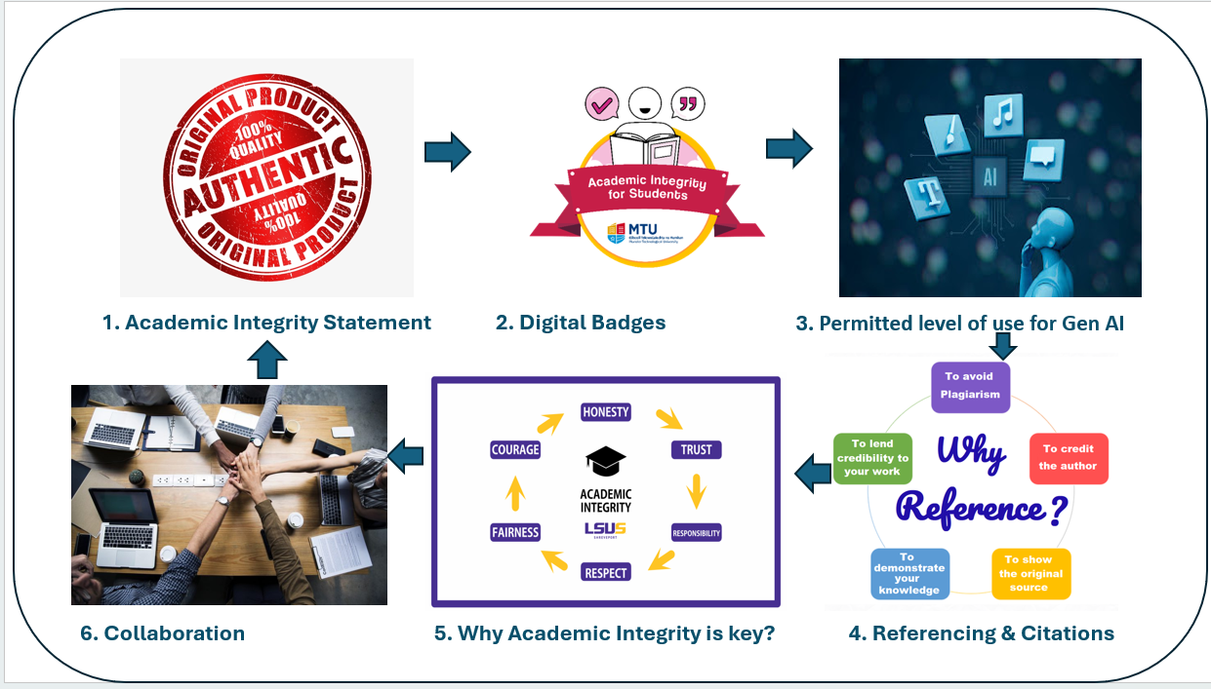
This table sets out the options under consideration in this guideline document:
Option | Useful for Prog. stages | Relevant Assessment | Timing
- Academic integrity Statement | All | All | Upon submission of assessment
- Digital badges – Evidence of completion | Post semester one year one. | All | Upon submission of assessment
- Permitted level of use for Gen AI | All | All | Detailed at time of release of assessment
- Referencing & Citations | All | All | Detailed at time of release of assessment
- Department teaching slide deck | All | All | Prior to assessment
- Collaboration and feedback | All | All | Anytime during semester

This guideline document is hosted on the Department of Management & Enterprise Teams site as a live document which can be updated to reflect MTU changes in policy and practices linked to supporting academic integrity. The guidelines were drafted over three iterations before being launched in June 2025. The draft document was developed initially by Caroline O’Reilly, Head of Department of Management & Enterprise and refined following consultation with the following;
- Dr. Violeta Morari and Dr. Áine Ni She MTU SATLE funded project supporting AI
- Dr. Angela Wright, Prof. Jim O Mahony, Sinead Huskisson and Sharon Lehane, MTU Teaching & Learning Unit
- Dr. Jean Ricken and Michael Costello, MTU Library
- Dr. Gearoid O Suilleabhain and Darragh Coakley, Dept of Technology Enhanced Learning
- 16 coordinators (lecurers) supporting programmes in the Dept. of Management & Enterprise.
The draft guidelines was a launched via two online workshops in June 2025. A total of 90 lecturers were invited to attend one of these sessions and approximately 45 attended.
In September 2025 the guidelines were presented to MTU registrar Professor Christine Cross. The document was positively received and a request followed that the guideline document be shared more widely and a commitment was given that the Faculty of Business Departments would adopt the guidelines during the pilot phase.
Finally, the guideline document was again presented to the Department of Management & Enterprise lecturers as part of a department briefing session which was accepted by 42 lecturers.
At the end of semester two AY25_26 lecturers will be asked to provide feedback on the guidelines and six options. Subject to lecturer demand and engagement a student facing resource will be developed to assist students directly with advice and guidance on how best to access and use MTU resources to support their academic integrity practices.
The guideline is not a whole response to Academic Integrity and it is expected that it will be replaced in time with a university wide MTU approach. These guidelines seek to support and is guided by MTU policy and procedures which take precedent in supporting Academic Integrity
Prepared by Caroline O’Reilly
Head of Department of Management & Enterprise
5th Jan 2026

